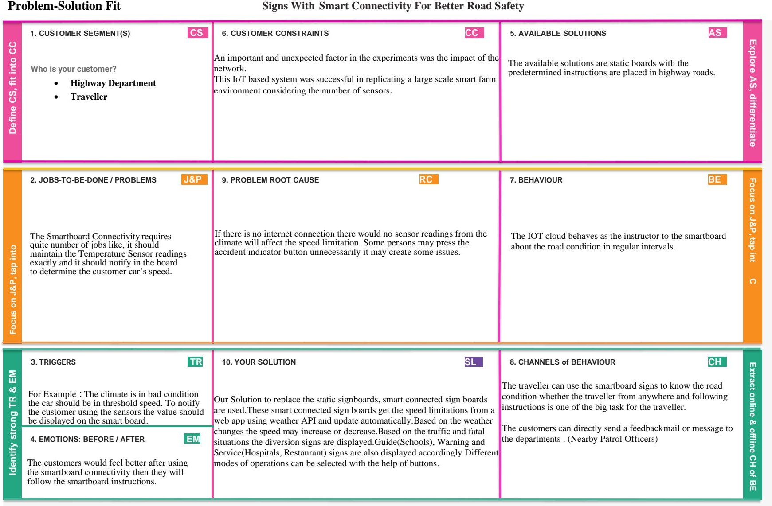r

SIGNS WITH DATA MINING TECHNIQUES FOR ESTIMATION CROP

There is a growing number of application of data mining techniques in agriculture and a growing amount of data that are currently available from any sources. This is relatively expected to grow in the future. The multidisciplinary approach of integrating computer science with agriculture will help in forecasting/ managing agriculture crops effectively.

The traveller can use the smartboard signs to know the climate condition whether the framers can able to follow the instruction but it’s one of the big task for framers.

The framer would feel better after using the data mining connectivity then they will follow the smart device in data mining.

For eg: The climate is in bad condition the crop in safe condition.to notify the framer using the sensor the value should be display on the smart device with data mining

The IOT devices behaves as the instructor to the smartboard about the weather condition in regular intervals.

The available solutions are static boards with the predetermined instructions are placed in agriculture fields.

An important and unexpected factor in the experiments was the impact of the network.

This IoT based system was successful in replicating a large scale environment considering the number of sensors.

If there is no internet connection there would no senser readings from the climate will affect the crops production.

Most of the research papers examined considered climatic variables such as, area, Temperature, Precipitation, and Humidity. Some soil agronomical parameters, such as chalky, clay, loamy, sandy, and so on, as well as different seasons, are included. The data of these variables were given as input. Initially dataset is collected which consisting of the parameters such as attributes like State Name, District name humidity, temperature, yield etc. Take into consideration any crops that will be planted in the region. This collected dataset is in csv format.

* FARMER